Workshop on Smart Bioelectronic and Wearable Systems

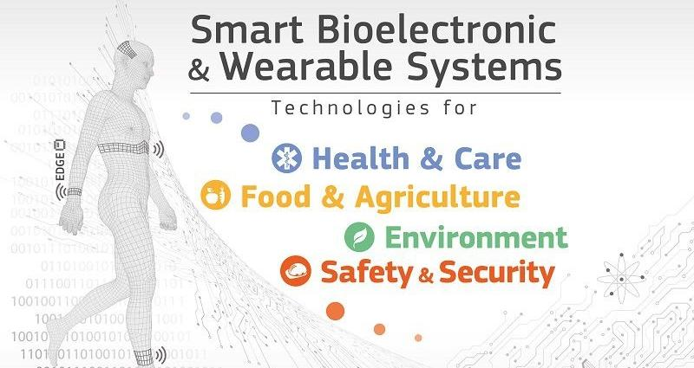

This two day EC workshop, covering smart systems across Key Digital Technologies, with an emphasis on bio-electronics, bio-photonics and flexible and wearable electronics, will raise their importance and role in addressing European competitiveness and major societal challenges and link the area with current technology and policy trends.

Building on the success of previous events on Micro-Nano-Bio Systems [MNBS](https://ec.europa.eu/digital-single-market/news-redirect/632880), [Biophotonics](https://ec.europa.eu/digital-single-market/en/news/performance-assessement-and-standardization-biophotonics-workshop) and [Flexible & Wearable Electronics](https://ec.europa.eu/digital-single-market/news-redirect/637852), this workshop will bring together EC-funded projects and stakeholders to share technology and innovation progress, and address future challenges. The event will cover the whole value chain, from research to market in key applications.

For more information and registration, click [here](https://ec.europa.eu/digital-single-market/en/news/workshop-smart-bioelectronic-and-wearable-systems).